PRACTICAL ASSIGNMENT- 6

* Name: Hardik Arora
* Branch : Btech - CS
* Program: AIML
* University Roll No. : 2215500071
* Section: 2AC
* Class Roll No. : 28

CREATE DATABASE P6;

USE P6;

CREATE TABLE IF NOT EXISTS Student (

    sID INT PRIMARY KEY,

    sName VARCHAR(50),

    GPA FLOAT,

    sizeHS INT NOT NULL,

    DoB VARCHAR(50)

);

INSERT INTO student(sID, sName, GPA, sizeHS, DoB) VALUES ('123', 'Amy', '3.9', '1000', '1996-06-26');

INSERT INTO student(sID, sName, GPA, sizeHS, DoB) VALUES ('234', 'Bob', '3.6', '1500', '1995-04-07');

INSERT INTO student(sID, sName, GPA, sizeHS, DoB) VALUES ('345', 'Craig', '3.5', '500', '1995-02-04');

INSERT INTO student(sID, sName, GPA, sizeHS, DoB) VALUES ('456', 'Doris', '3.9', '1000', '1997-07-24');

INSERT INTO student(sID, sName, GPA, sizeHS, DoB) VALUES ('567', 'Edward', '2.9', '2000', '1996-12-21');

INSERT INTO student(sID, sName, GPA, sizeHS, DoB) VALUES ('678', 'Fay', '3.8', '200', '1996-08-27');

INSERT INTO student(sID, sName, GPA, sizeHS, DoB) VALUES ('789', 'Gary', '3.4', '800', '1996-10-08');

INSERT INTO student(sID, sName, GPA, sizeHS, DoB) VALUES ('987', 'Helen', '3.7', '800', '1997-03-27');

INSERT INTO student(sID, sName, GPA, sizeHS, DoB) VALUES ('876', 'Irene', '3.9', '400', '1996-03-07');

INSERT INTO student(sID, sName, GPA, sizeHS, DoB) VALUES ('765', 'Jay', '2.9', '1500', '1998-08-08');

INSERT INTO student (sID, sName, GPA, sizeHS, DoB) VALUES ('654', 'Amy', '3.9', '1000', '1996-05-26');

INSERT INTO student (sID, sName, GPA, sizeHS, DoB) VALUES ('543', 'Craig', '3.4', '2000', '1998-08-27');

SELECT * FROM student;

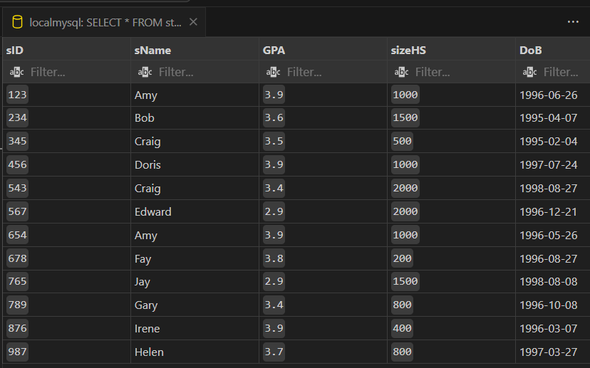

CREATE TABLE IF NOT EXISTS College(

    cName VARCHAR(50) PRIMARY KEY,

    State VARCHAR(50),

    enrollment INT NOT NULL

);

INSERT INTO college(cName, State, enrollment) VALUES('Stanford', 'CA', '15000');

INSERT INTO college(cName, State, enrollment) VALUES('Berkeley', 'CA', '36000');

INSERT INTO college(cName, State, enrollment) VALUES('MIT', 'MA', '10000');

INSERT INTO college(cName, State, enrollment) VALUES('Cornell', 'NY', '21000');

INSERT INTO college(cName, State, enrollment) VALUES('Harvard', 'MA', '50040');

SELECT * FROM college;

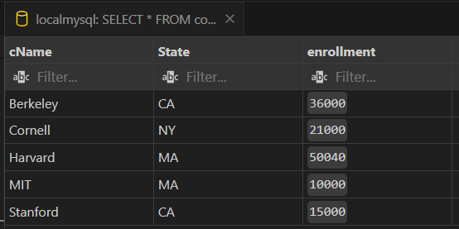

CREATE TABLE IF NOT EXISTS Applied(

    sID INT NOT NULL,

    cName VARCHAR(50) NOT NULL,

    major VARCHAR(50) NOT NULL,

    decision VARCHAR(1) NOT NULL

);

INSERT INTO Applied(sID, cName, major, decision) VALUES('123', 'Stanford', 'CS', 'Y');

INSERT INTO Applied(sID, cName, major, decision) VALUES('123', 'Stanford', 'EE', 'N');

INSERT INTO Applied(sID, cName, major, decision) VALUES('123', 'Berkeley', 'CS', 'Y');

INSERT INTO Applied(sID, cName, major, decision) VALUES('123', 'Cornell', 'EE', 'Y');

INSERT INTO Applied(sID, cName, major, decision) VALUES('234', 'Berkeley', 'biology', 'N');

INSERT INTO Applied(sID, cName, major, decision) VALUES('345', 'MIT', 'bioengineering', 'Y');

INSERT INTO Applied(sID, cName, major, decision) VALUES('345', 'Cornell', 'bioengineering', 'N');

INSERT INTO Applied(sID, cName, major, decision) VALUES('345', 'Cornell', 'CS', 'Y');

INSERT INTO Applied(sID, cName, major, decision) VALUES('345', 'Cornell', 'EE', 'N');

INSERT INTO Applied(sID, cName, major, decision) VALUES('678', 'Stanford', 'history', 'Y');

INSERT INTO Applied(sID, cName, major, decision) VALUES('987', 'Stanford', 'CS', 'Y');

INSERT INTO Applied(sID, cName, major, decision) VALUES('987', 'Berkeley', 'CS', 'Y');

INSERT INTO Applied(sID, cName, major, decision) VALUES('876', 'Stanford', 'CS', 'N');

INSERT INTO Applied(sID, cName, major, decision) VALUES('876', 'MIT', 'biology', 'Y');

INSERT INTO applied(sID, cName, major, decision) VALUES('876', 'MIT', 'marine biology', 'N');

INSERT INTO Applied(sID, cName, major, decision) VALUES('765', 'Stanford', 'history', 'Y');

INSERT INTO applied(sID, cName, major, decision) VALUES('765', 'Stanford', 'history', 'N');

INSERT INTO applied(sID, cName, major, decision) VALUES('765', 'Cornell', 'history', 'N');

INSERT INTO applied(sID, cName, major, decision) VALUES('765', 'Cornell', 'psychology', 'Y');

INSERT INTO applied(sID, cName, major, decision) VALUES('543', 'MIT', 'CS', 'N');

SELECT * FROM applied;

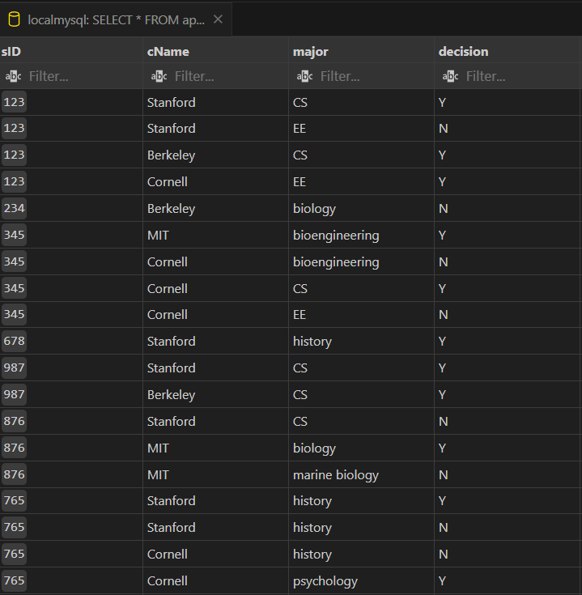

# Write SQL queries for the following:

Q1. Create a new column DoB in Student table. (Datatype will be date)

ALTER TABLE Student

ADD COLUMN DoB DATE;

Q2. Insert DoB for each Student in corresponding table using above instance of Student table.

UPDATE Student SET DoB = '1996-06-26' WHERE sID = '123';

UPDATE Student SET DoB = '1995-04-07' WHERE sID = '234';

UPDATE Student SET DoB = '1995-02-04' WHERE sID = '345';

UPDATE Student SET DoB = '1997-07-24' WHERE sID = '456';

UPDATE Student SET DoB = '1996-12-21' WHERE sID = '567';

UPDATE Student SET DoB = '1996-08-27' WHERE sID = '678';

UPDATE Student SET DoB = '1996-10-08' WHERE sID = '789';

UPDATE Student SET DoB = '1997-03-27' WHERE sID = '987';

UPDATE Student SET DoB = '1996-03-07' WHERE sID = '876';

UPDATE Student SET DoB = '1998-08-08' WHERE sID = '765';

UPDATE Student SET DoB = '1996-05-26' WHERE sID = '654';

UPDATE Student SET DoB = '1998-08-27' WHERE sID = '543';

Q3. Find average of GPA round off to 2 decimal places.

SELECT ROUND(AVG(GPA), 2) AS average_gpa FROM Student;

Q4. Find year of DoB of Student having less than 1000.

SELECT YEAR(DoB) AS birth_year FROM Student WHERE sizeHS < 1000;

Q5. Compute Age of each student. (Hint: take difference between year of sysdate and Student’s DoB)

SELECT sName, YEAR(CURRENT_DATE()) - YEAR(DoB) - (DATE_FORMAT(CURRENT_DATE(), '%m%d') < DATE_FORMAT(DoB, '%m%d')) AS age FROM Student;

Q6. Display name of all Students in uppercase and name of college they applied in lower case.

SELECT UPPER(sName) AS student_name, LOWER(cName) AS college_name FROM Student JOIN Applied ON Student.sID = Applied.sID;

Q7. Find fourth alphabet of each student. (Hint: use substring)

SELECT SUBSTRING(sName, 4, 1) AS fourth_alphabet FROM Student;

Q8. Find sID and sName of student whose sName has string length greater than 3.

SELECT sID, sName FROM Student WHERE LENGTH(sName) > 3;

Q9. Find floor, ceiling and truncate (to one decimal place) value of average GPA.

SELECT FLOOR(AVG(GPA)) AS floor_value, CEILING(AVG(GPA)) AS ceiling_value, TRUNCATE(AVG(GPA), 1) AS truncated_value FROM Student;

Q10. Display details of all students whose sID is even.

SELECT * FROM Student WHERE sID % 2 = 0;

Q11. Compute Square Root of 900 and 24^7.

SELECT SQRT(900) AS square_root_900, SQRT(247) AS square_root_247;

Q12. Consider the string “Peter Piper picked a peck of pickled peppers. A peck of pickled peppers Peter Piper picked. If Peter Piper picked a peck of pickled peppers, Where the peck of pickled peppers Peter Piper picked?” Find 6th occurrence of string ‘pick’. (Hint: use INSTR)

SELECT INSTR('Peter Piper picked a peck of pickled peppers. A peck of pickled peppers Peter Piper picked. If Peter Piper picked a peck of pickled peppers, Where the peck of pickled peppers Peter Piper picked?', 'pick', 1, 6) AS sixth_occurrence_position;

Q13. Consider String ‘Satya Nadella’ replace this using the key (Hint: use translate)

SELECT TRANSLATE('Satya Nadella', 'aelNST123456y7', 'eaelNS1t234567y7') AS replaced_string;

Q14. Display sID, sname and DoB in this format ‘February 26, 2014’

SELECT sID, sname, DATE_FORMAT(DoB, '%M %e, %Y') AS formatted_date FROM Student;

Q15. Convert the text ’26/02/2014’ to date.

SELECT STR_TO_DATE('26/02/2014', '%d/%m/%Y') AS converted_date;

Q16. Compute on which date is next Saturday and last day of this month?

SELECT DATE_ADD(CURRENT_DATE(), INTERVAL (7 - DAYOFWEEK(CURRENT_DATE())) DAY) AS next_saturday;

SELECT LAST_DAY(CURRENT_DATE()) AS last_day_of_month;

# Exercise:

Q1. Display sID, sname and DoB in this format ‘26th Feburary, 2014’

SELECT sID, sname, DATE_FORMAT(DoB, '%D %M, %Y') AS formatted_date FROM Student;

Q2. Display sID, sname and DoB in this format ‘26/02/2014’

SELECT sID, sname, DATE_FORMAT(DoB, '%d/%m/%Y') AS formatted_date FROM Student;

Q3. Add 5 months to DoB of Edward?

UPDATE Student SET DoB = DATE_ADD(DoB, INTERVAL 5 MONTH) WHERE sName = 'Edward';

Q4. Display last day of DoB of Amy?

SELECT LAST_DAY(DoB) AS last_day_of_birth FROM Student WHERE sName = 'Amy';

Q5. Display next Sunday of DoB of Doris?

SELECT DATE_ADD(DoB, INTERVAL (8 - DAYOFWEEK(DoB)) DAY) AS next_sunday FROM Student WHERE sName = 'Doris';

* Name: Hardik Arora
* Branch : Btech - CS
* Program: AIML
* University Roll No. : 2215500071
* Section: 2AC
* Class Roll No. : 28
* Submitted to: Ayushi Mam
* Submitted on: 06-05-2024